PROJECT REPORT

TITLE: Comprehensive Analysis and Dietary Strategies with Tableau: A College Food Choices Case Study

- INTRODUCTION  - Project Overview | - | 1-2
1.2 Purpose
- IDEATION PHASE  - Problem Statement | - | 2-4
2.2 Empathy Map Canvas
2.3 Brainstorming
3. REQUIREMENT ANALYSIS | - | 4-7
3.1 Customer Journey map
3.2 Solution Requirement
3.3 Data Flow Diagram
3.4 Technology Stack
4. PROJECT DESIGN | - | 7-9
4.1 Problem Solution Fit
4.2 Proposed Solution
4.3 Solution Architecture
- PROJECT PLANNING & SCHEDULING  - Project Planning | - | 9-11
5.2 Planning Logic
6. FUNCTIONAL AND PERFORMANCE TESTING | - | 11-12
6.1 Performance Testing
- RESULTS  - Output Screenshots | - | 12-20
8. ADVANTAGES & DISADVANTAGES | - | 20-21
9. CONCLUSION | - | 22
10. FUTURE SCOPE | - | 22
11. APPENDIX | - | 23-27
Source Code (if any) Dataset Link
GitHub & Project Demo Link

INTRODUCTION

Project Overview

As a college health and wellness administrator, my mission is to proactively support the nutritional well-being of students. However, our current understanding of student dietary behaviours is hindered by fragmented, static, or siloed data. Without timely, actionable insights, our ability to address nutritional deficiencies and trends in real-time is limited - leaving us in a largely reactive position.

Purpose

The primary purpose of this project is to develop an interactive, data-driven platform using Tableau that enables college wellness administrators to:
    - Understand and track student eating behaviours in real-time.
    - Identify nutritional deficiencies and food trends across the student population.
    - Enhance collaboration between health services and dining operations.
    - Support evidence-based wellness programs and menu improvements that promote healthier eating on campus.

IDEATION PHASE

Problem Statement

I am a college health and wellness administrator
I’m trying to understand and improve the dietary and nutritional habits of students But I lack real-time, visual insights into eating behaviors, health trends, and deficiencies Because the data is scattered, static, or underutilized for strategic wellness interventions Which makes me feel reactive and under-equipped to support student health proactively.
PS-1: I am a student affairs officer who wants to monitor student nutrition habits to prevent health issues, but I don't have access to interactive tools that give real-time data on students’ dietary trends.
PS-2: I am a university nutritionist trying to detect deficiencies in students’ diets, but it’s difficult to pinpoint problem areas without an integrated platform that shows snack overconsumption, vitamin neglect, and health perception metrics.
PS-3: I am a wellness strategist aiming to develop personalized health plans for students, but predictive analytics tools are not in place to proactively identify high- risk individuals and suggest tailored interventions.

Empathy Map
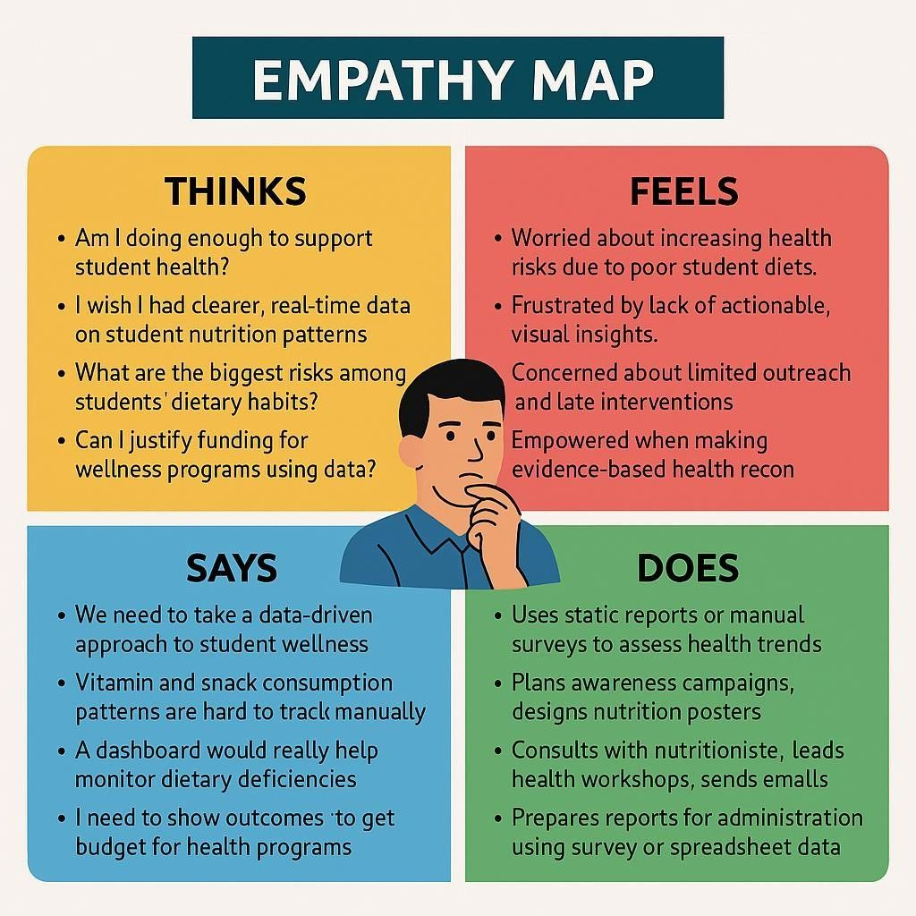

Brainstorming

Grouping Category | Ideas Generated
Nutritional  Monitoring | Track fruit and vegetable intake trends by gender, age, and  exercise frequency
Deficiency Detection | Identify vitamin intake gaps and high snack consumption  patterns
Predictive Health  Insights | Classify students into nutrition risk groups (High, Moderate,  Low)
Visualization Tools | Use bar charts, scatter plots, heatmaps, and KPI cards in  Tableau
Real-Time Alerts | Trigger alerts for low fruit/veggie intake or high snack calorie  counts

Personalized Plans | Suggest meal plans and health guidance based on risk  classification
Awareness Campaigns | Develop education initiatives based on dietary trends found in  dashboards

Priority Level | Idea
High | Build Tableau dashboards for real-time intake monitoring
High | Classify students by risk using fruit and exercise data
Medium | Visualize snack consumption vs. health perception
Medium | Track vitamin intake by demographic
Low | Link Tableau to live cafeteria menu data (future implementation)
Low | Integrate AI-based meal suggestions (post MVP phase)

REQUIREMENT ANALYSIS

Customer Journey Map
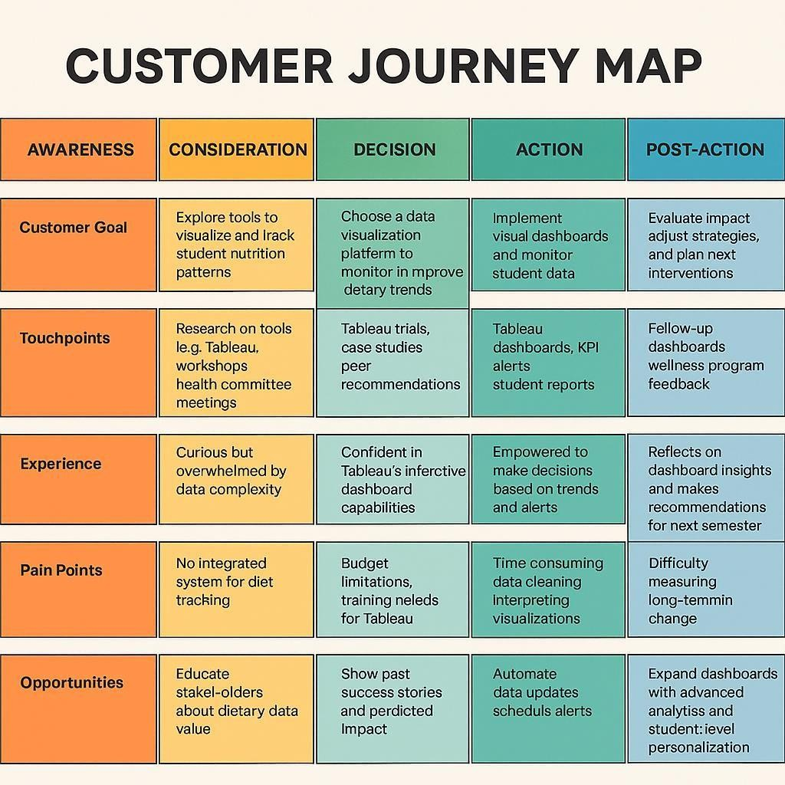

Solution Requirements Functional Requirements:

FR  No. | Functional Requirement  (Epic) | Sub Requirement (Story / Sub-Task)
FR-1 | User Registration | Registration through Form  Registration through Gmail Registration through LinkedIn
FR-2 | User Confirmation | Confirmation via Email  Confirmation via OTP
FR-3 | Data Visualization | Generate Pie Chart Generate Donut Chart Generate Area Chart  Generate Word Cloud
FR-4 | Data Filtering and Sorting | Filter by Date Range Sort by Total Sales  Filter by Branch or Product Line

Non-Functional Requirements:
FR  No. | Non-Functional Requirement | Description
NFR-1 | Usability | The system should have a user-friendly and  intuitive interface.
NFR-2 | Security | Secure login and user data encryption  should be implemented.
NFR-3 | Reliability | The system should perform consistently  under expected loads without failure.
NFR-4 | Performance | Visualizations should load within 3 seconds average.
NFR-5 | Availability | The system should be accessible 24/7 with minimum downtime.
NFR-6 | Scalability | Should be scalable to handle large datasets or more branches in the future.

on

Data Flow Diagram
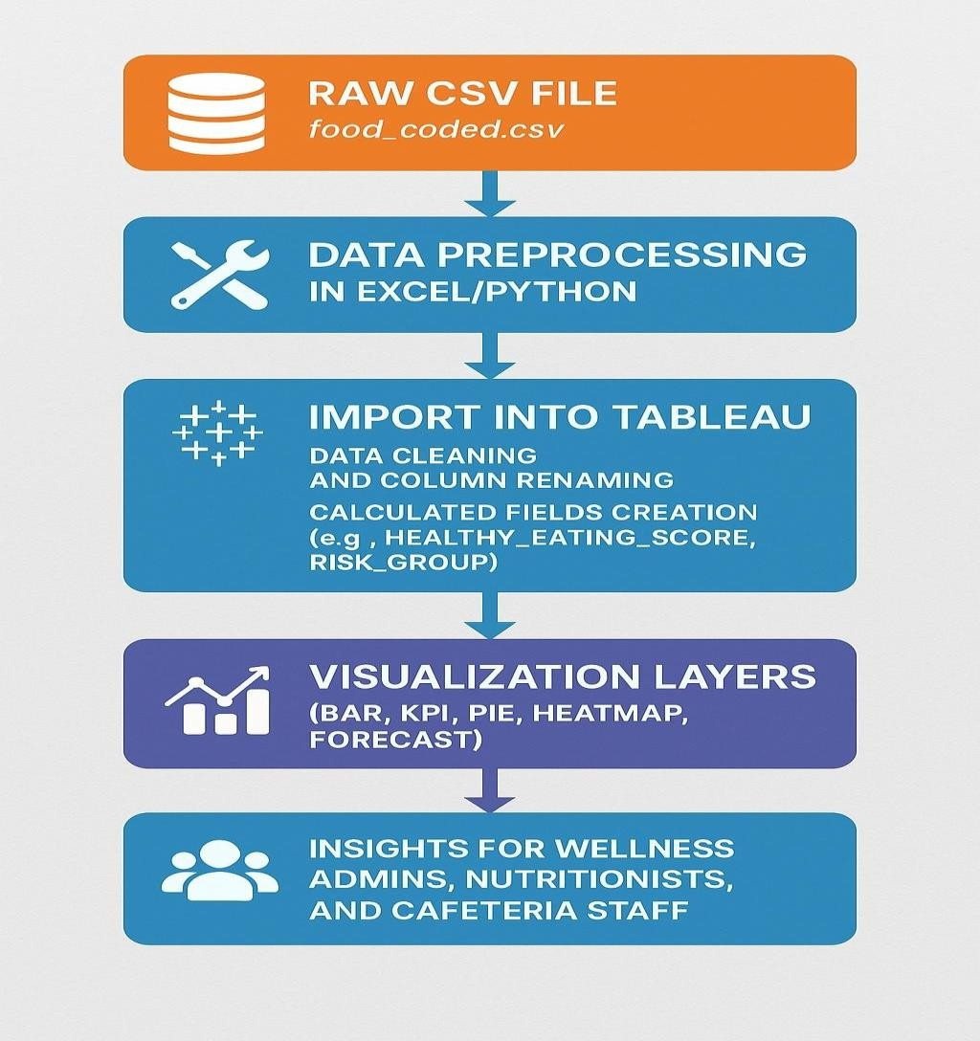

Technology Stack Data Layer
Component | Description
Dataset | food_coded.csv – structured CSV dataset capturing dietary and  health info
Storage Format | Flat file (CSV) loaded locally for analysis
Tools Used | Excel, Python (for cleaning & preprocessing if needed)

Data Processing Layer

Tool/Technology | Purpose

Python (Pandas) | Optional preprocessing: data cleaning, null handling, formatting
Excel | Initial cleaning or quick field review before importing to Tableau

Visualization & Analytics Layer

Tool/Technology | Purpose
Tableau | Main tool for interactive data visualization and dashboard  creation
Tableau Features | KPI cards, Bar Charts, Pie Charts, Heatmaps, Highlight Tables,  Forecasts
Calculated Fields | Used for: risk group classification, healthy eating score, snack  level

User Interaction Layer

Feature | Role
Interactive Dashboards | Users can filter data by gender, risk, and exercise levels
Parameter Controls | Customize target values (e.g., fruit intake threshold)

Feature | Role
Alerts & KPIs | Instant insight into nutrition deficiencies and trends
User Roles | Admin, Nutritionist, Cafeteria Staff – each interacts with  filtered views

Security & Sharing

Feature | Notes
Tableau Public | Public dashboards (for non-sensitive data)
Tableau Server | Optional upgrade for secured, role-based access
Export Options | PDF reports, public link sharing, dashboard embedding

PROJECT DESIGN

Problem Solution Fit
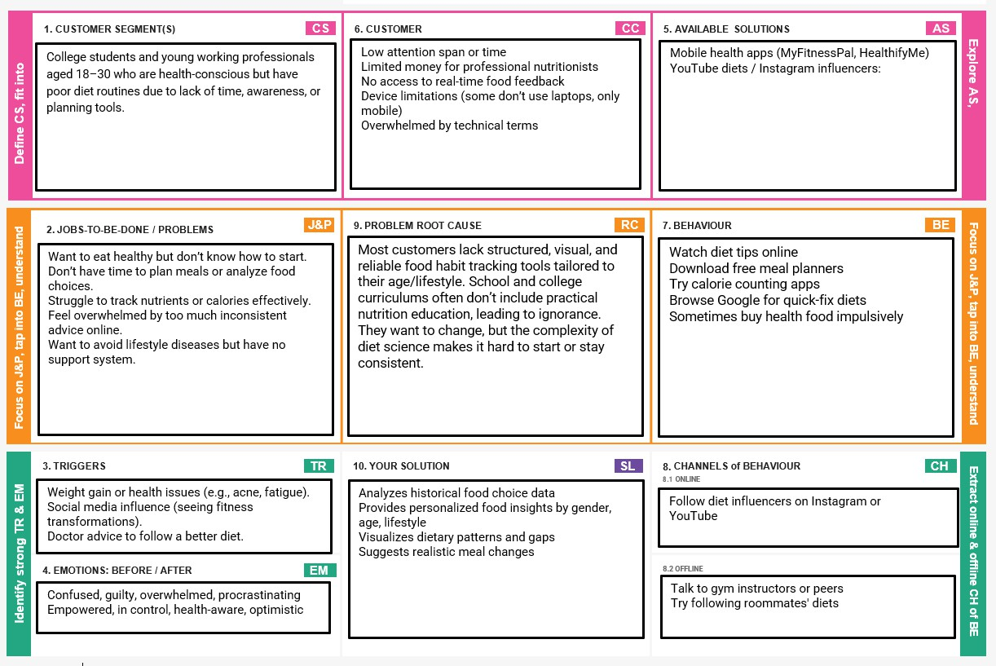

Proposed Solution

S.  No. | Parameter | Description
1. | Problem Statement (Problem to be solved) | Clearly describe the problem you aim to solve. Include relevant statistics or pain points to highlight the severity or urgency of  the issue.
2. | Idea / Solution description | Outline your proposed solution. Focus on how it addresses the problem effectively and  efficiently.
3. | Novelty / Uniqueness | What makes your solution different from existing ones? Highlight any innovative  features, technologies, or processes.
4. | Social Impact / Customer Satisfaction | Explain how your solution improves lives, benefits communities, or enhances customer  satisfaction.
5. | Business Model (Revenue Model) | How will the solution generate revenue? Include pricing strategies, partnerships,  target customer segments, etc.

6. | Scalability of the Solution | Discuss how your solution can grow geographically or serve more users. Mention potential challenges and how they will be  handled.

Solution Architecture
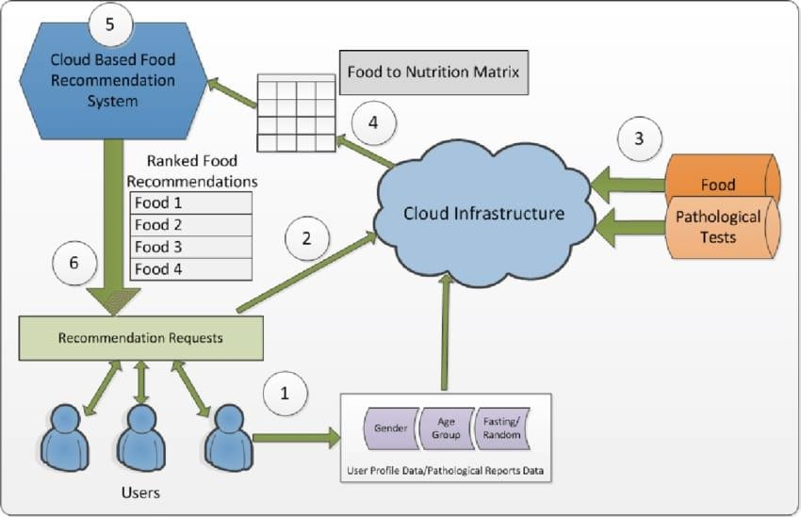

PROJECT PLANNING AND SCHEDULING

Project Planning

Sprint | Functional Requirement  (Epic) | User Story Number | User Story / Task | Story Points | Priority
Sprint-1 | Registration | USN-1 | As a user, I can register for the application by entering my email, password, and confirming my  password. | 2 | High
Sprint-1 | Confirmation | USN-2 | As a user, I will  receive confirmation email once I have | 1 | High

registered for the
application
Sprint-2 | Use Registration | USN-3 | As a user, I can register for the application through  Facebook | 2 | Low
Sprint-1 | Registration | USN-4 | As a user, I can register for the application through  Gmail | 2 | Medium
Sprint-1 | Login | USN-5 | As a user, I can log into the application by entering email &  password | 1 | High

Sprint | Total Story Points | Duration | Sprint Start Date | Sprint End Date (Planned) | Story Points Completed (as on Planned  End Date) | Sprint Release Date (Actual)
Sprint-1 | 20 | 6 Days | 24 Oct 2022 | 24 May 2025 | 20 | 24 May  2025
Sprint-2 | 20 | 6 Days | 31 Oct 2022 | 31 May 2025 | 20 | 31 May  2025
Sprint-3 | 20 | 6 Days | 07 Nov 2022 | 07 June 2025 | 20 | 07 June  2025
Sprint-4 | 20 | 6 Days | 14 Nov 2022 | 14 June 2025 | 20 | 14 June  2025

Planning Logic

A Sprint fixed period or duration in which a team works to complete a set of tasks
An Epic is a big task or project that is too large to complete in one sprint. It is broken down into smaller tasks (stories) that can be completed over multiple sprints.
A Story is a small task. It is part of an Epic.
A Story Point is a number that represents how much effort a story takes to complete. (usually in form of Fibonacci series)

Sprint 1: (6 Days)
Data Collection

Collection of Data 2
Loading Data 1

Sprint 2: (6 Days)
Data Preprocessing
Handling Missing Values 3
Handling Categorical values 2 Sprint 3: (6 Days)
Model Building
Model Building 5
Testing Model 3

Sprint 4: (6 Days)
Deployment
Working HTML Pages 3
Flask deployment 5

Total Story Points
Sprint 1 = 8
Sprint 2 = 16

Velocity= Total Story Points Completed/ Number of Sprints Total story Points= 16+8 =24
No of Sprints= 2
Velocity = (16+8)/2= 24/2 12 (Story Points per Sprint)
Team’s velocity is 12 Story Points per Sprint.

FUNCTIONAL AND PERFORMANCE TESTING

Performance Testing

S.  No. | Parameter | Screenshot / Values
1. | Data Rendered | 126 records
2. | Data Preprocessing | Removed null values
3. | Utilization of Filters | Date Range Filter Region Filter  Product Category Filter
4. | Calculation fields Used | Usually numeric, date/time, or text depending on the formula and context.
5. | Dashboard design | No of Visualizations / Graphs – 11  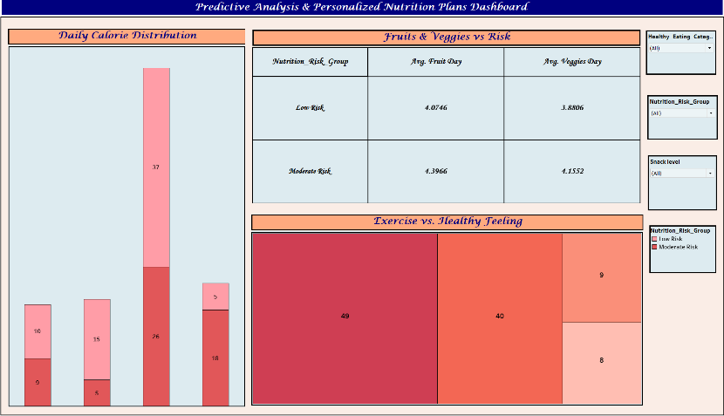
6 | Story Design | No of Visualizations / Graphs – 11  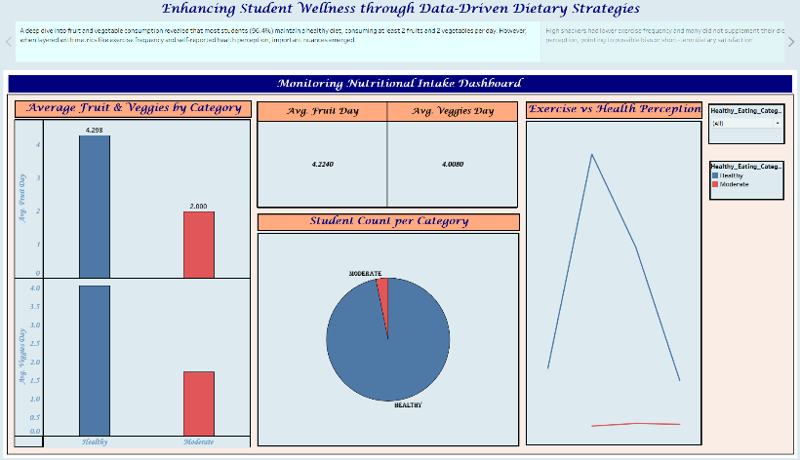

RESULTS

Output Screenshots

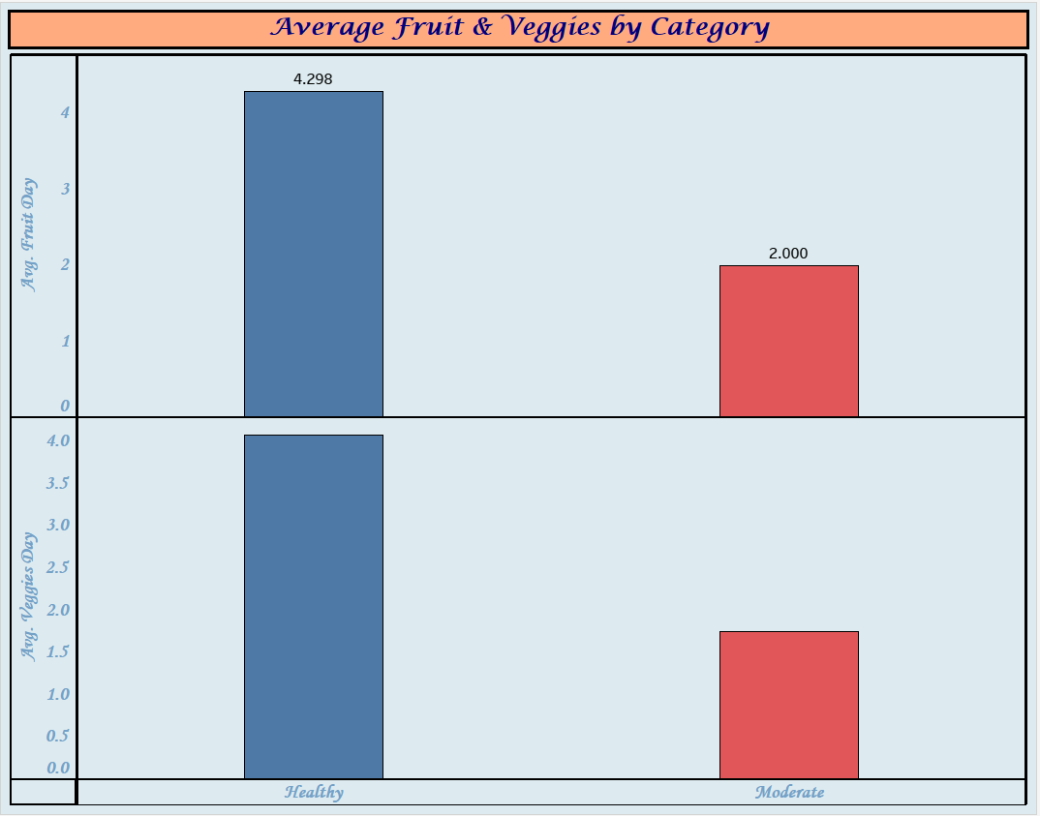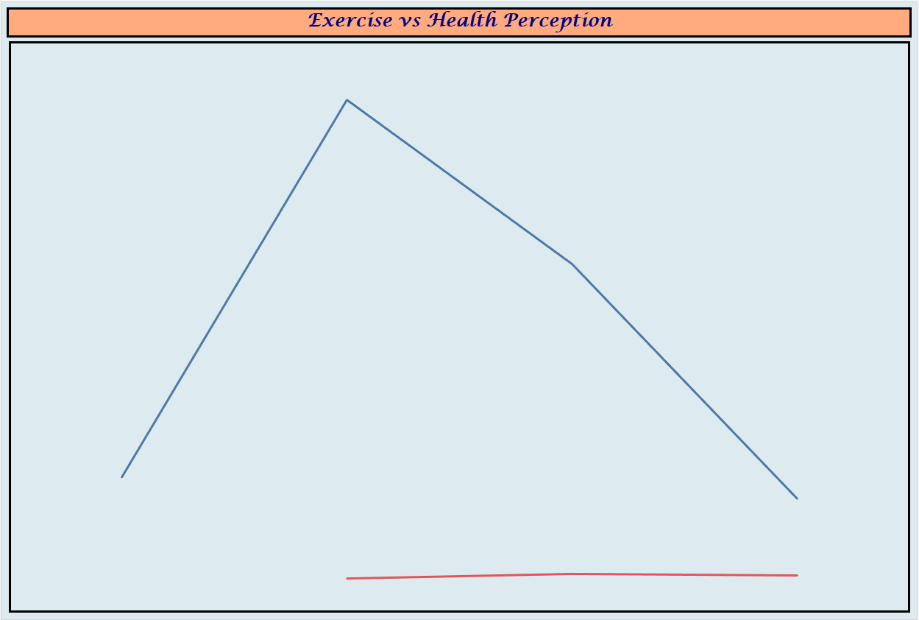

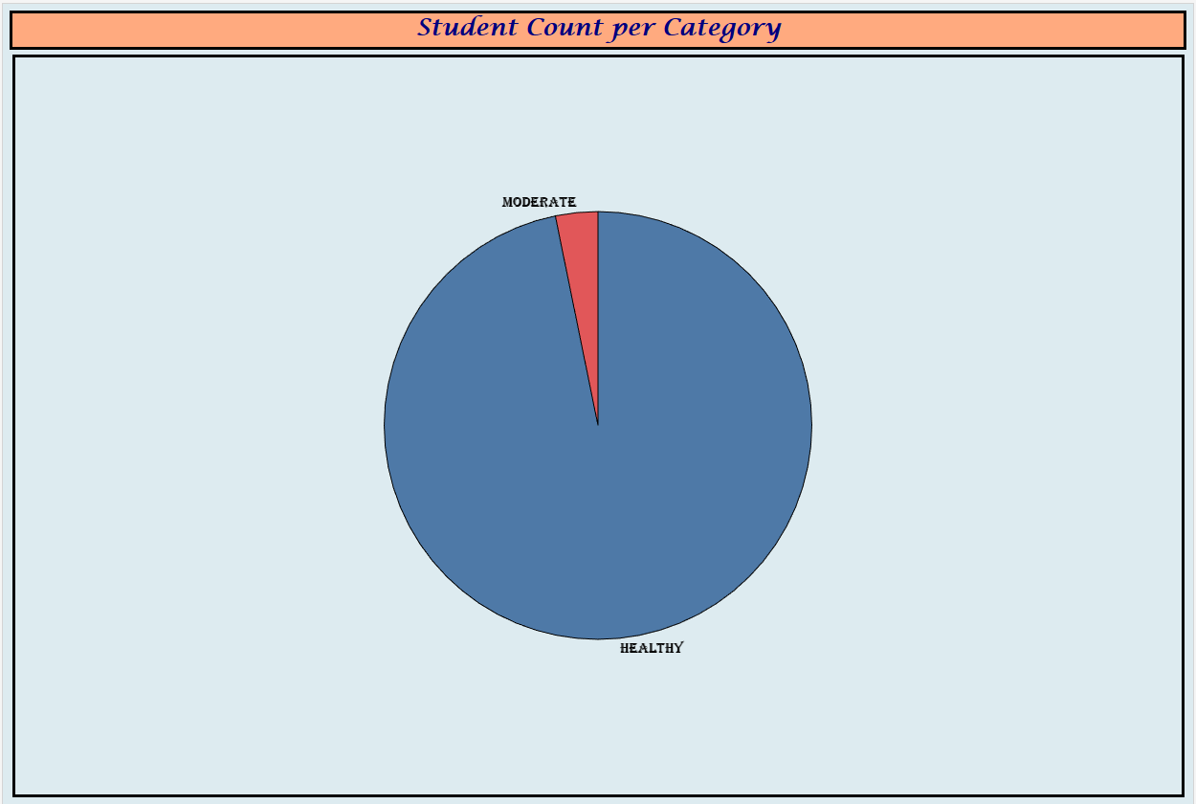

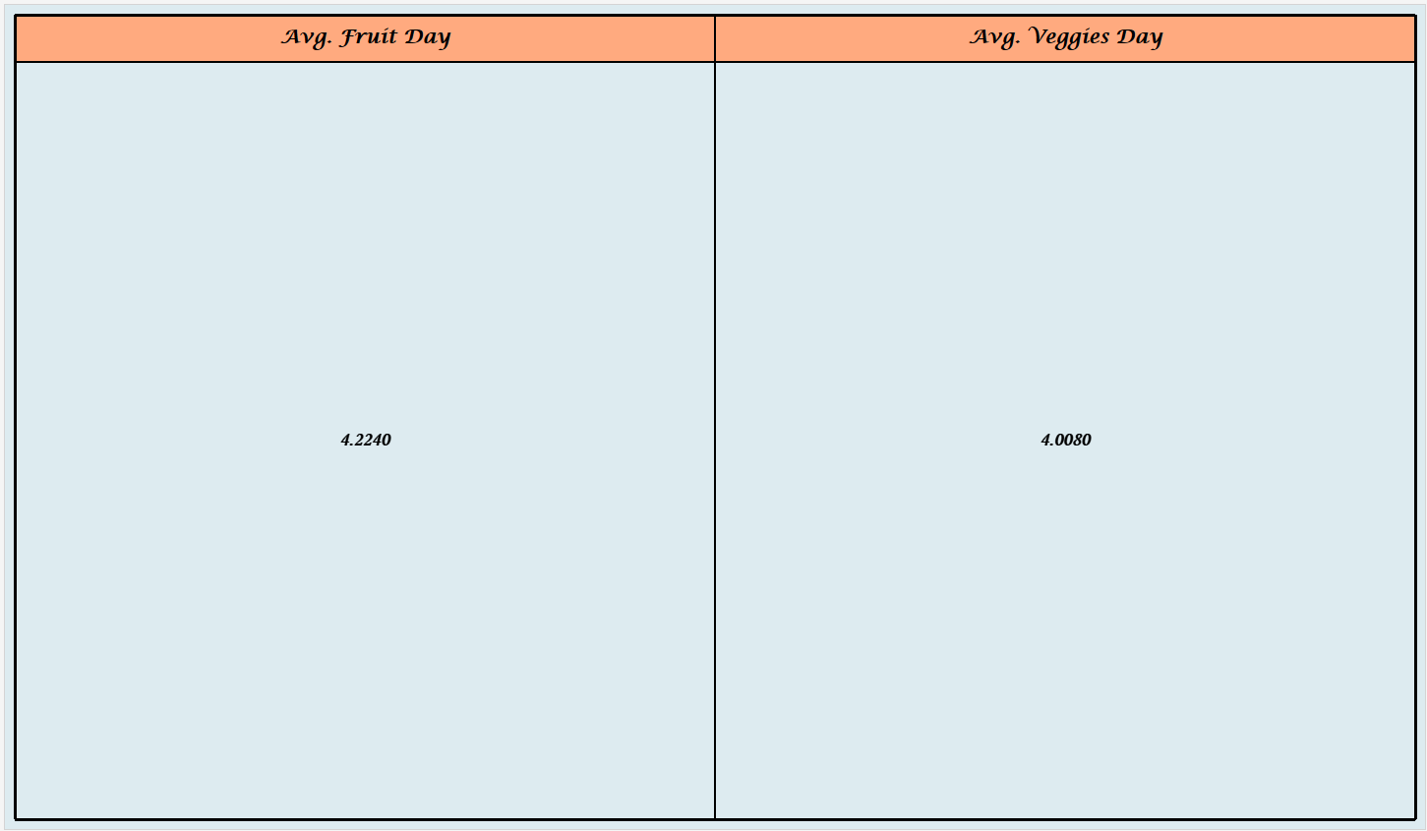

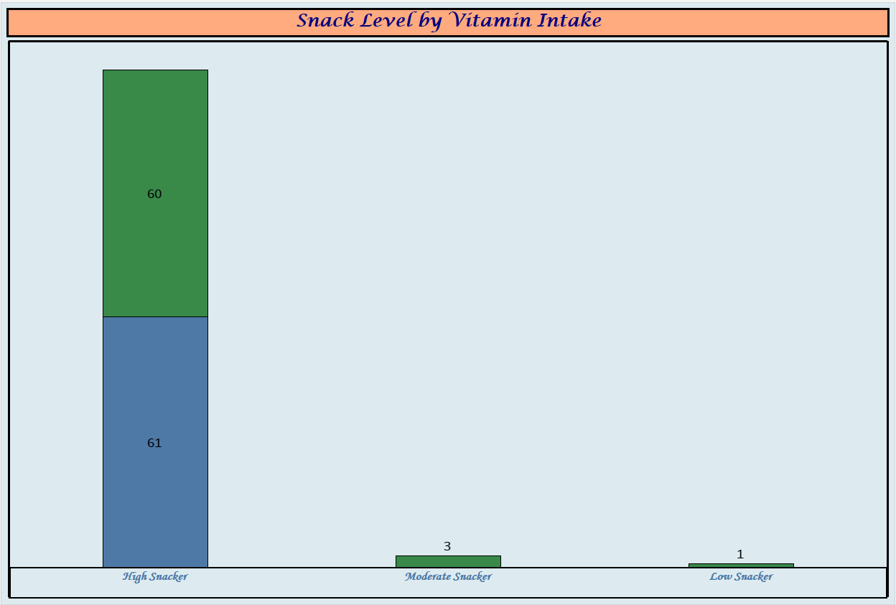

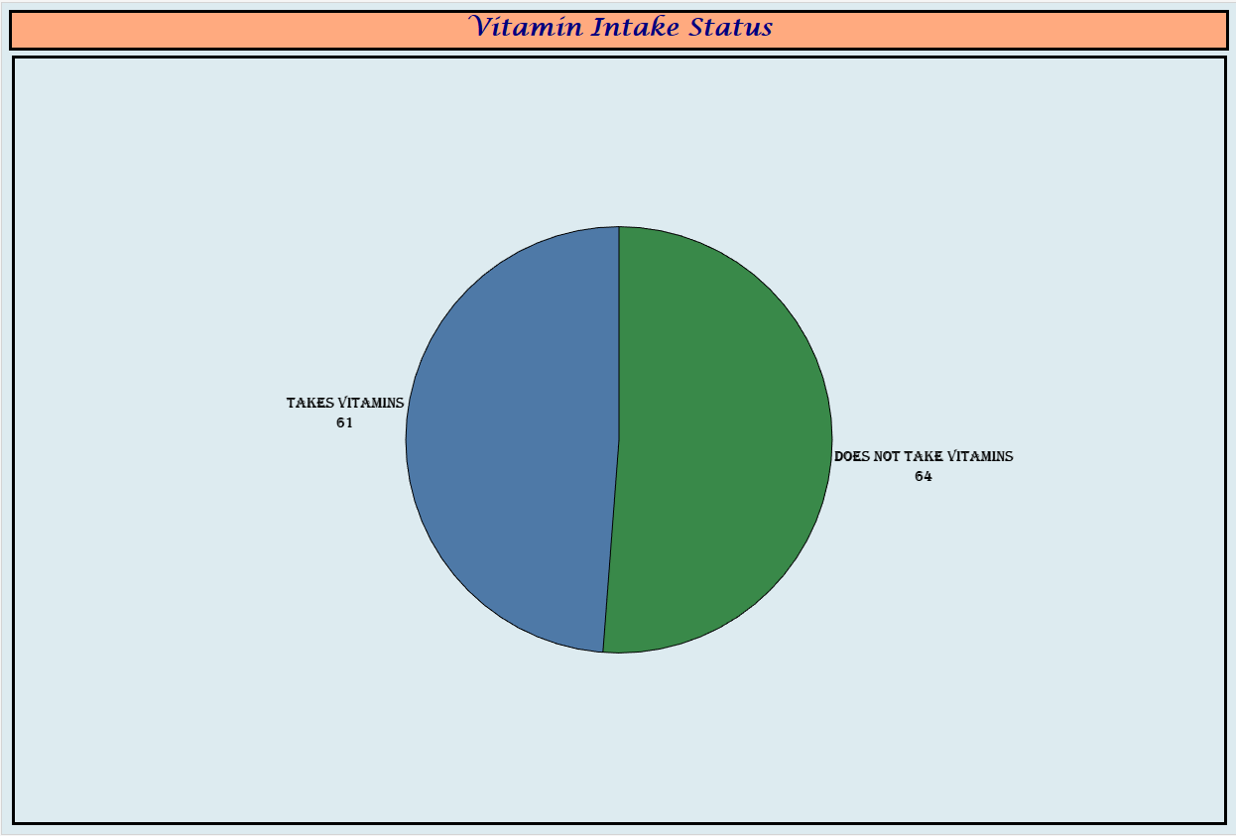

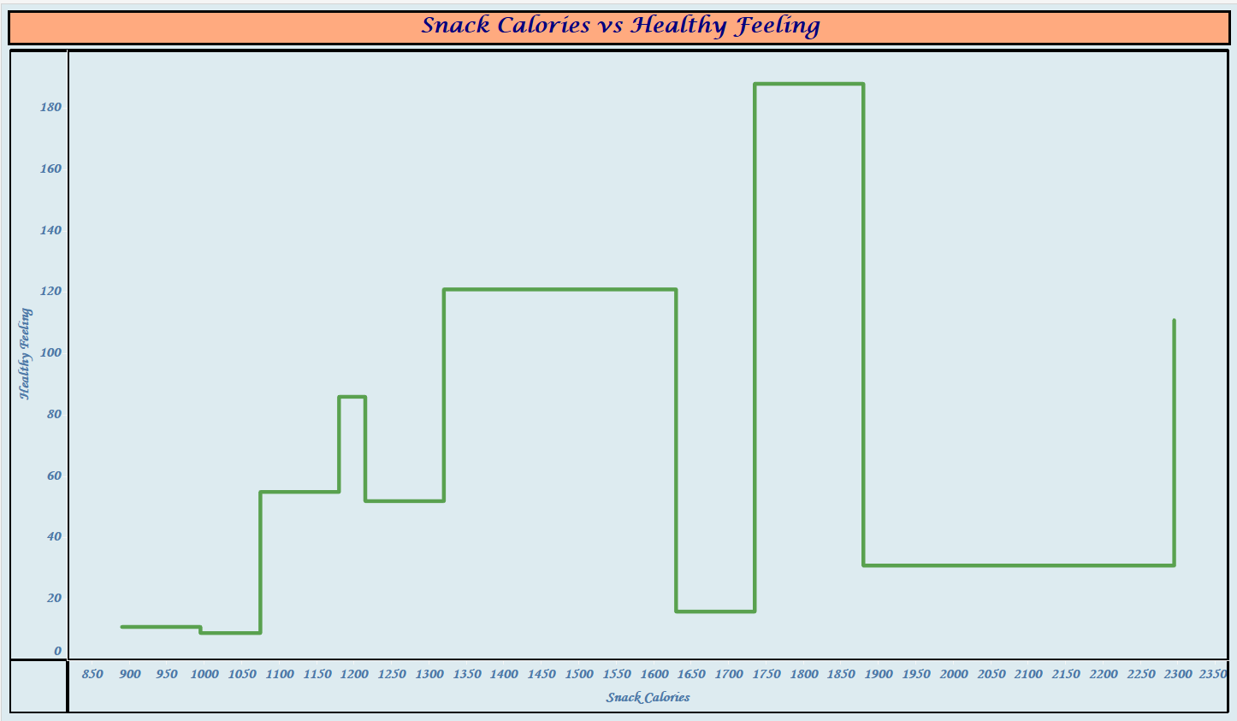

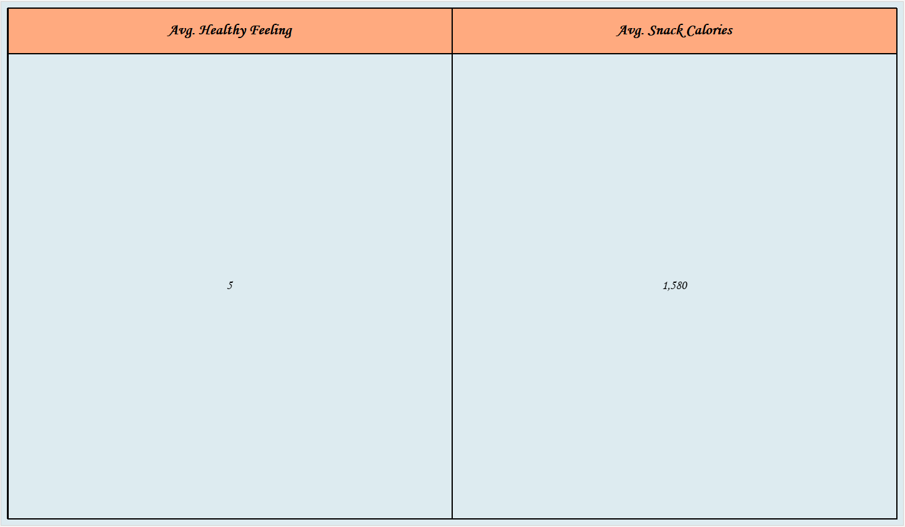

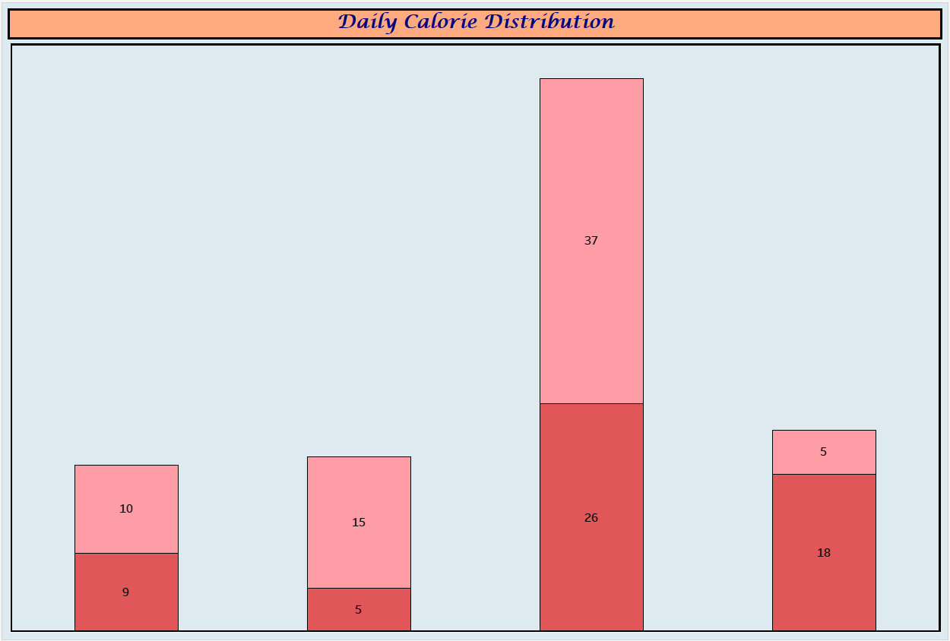

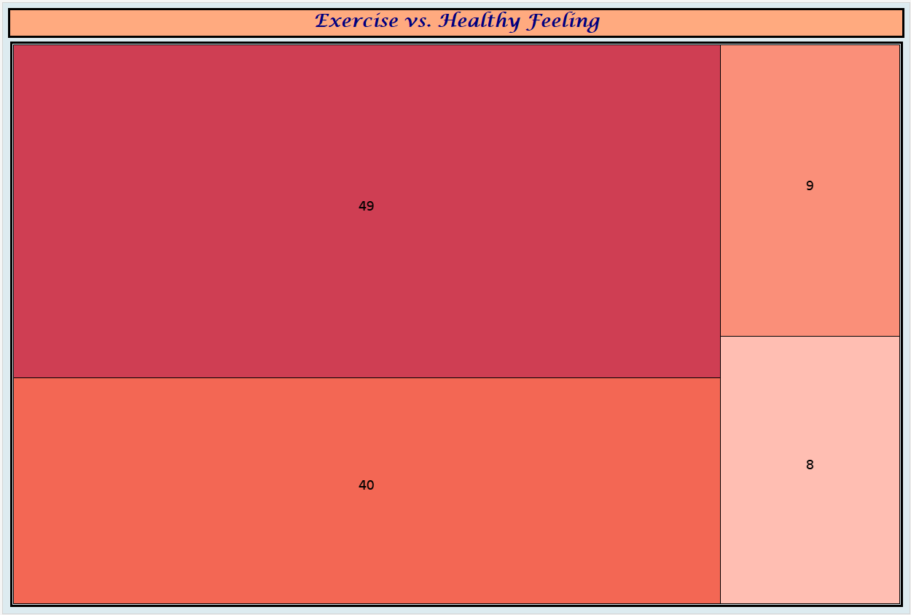

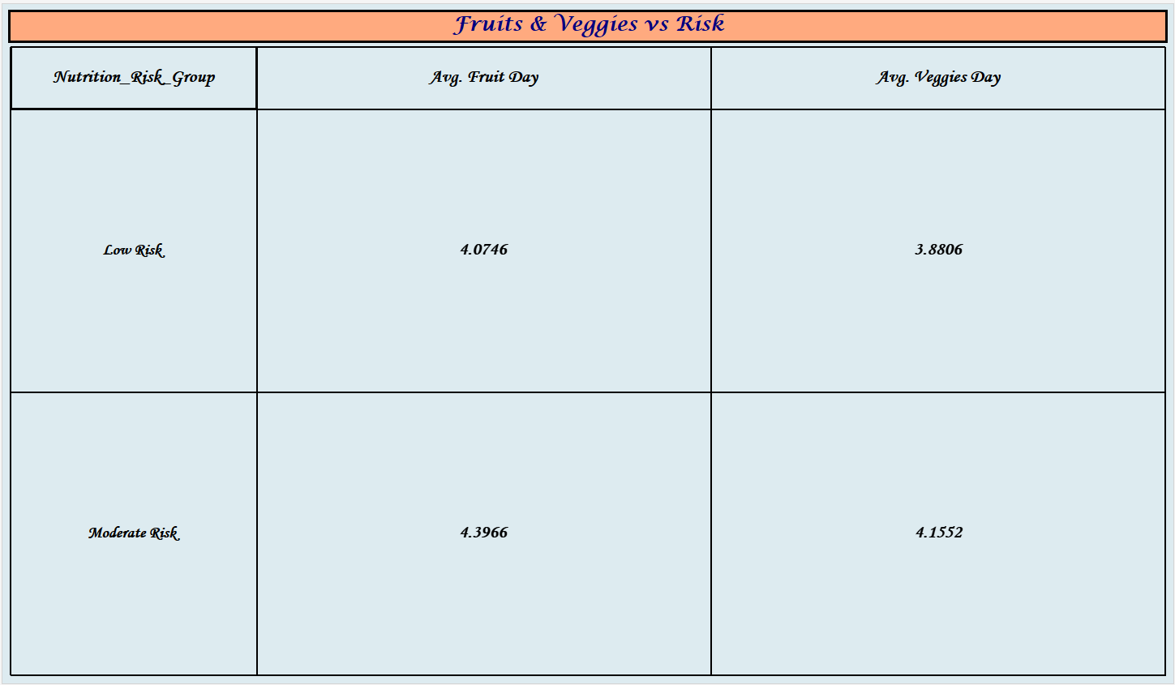

Dashboards:

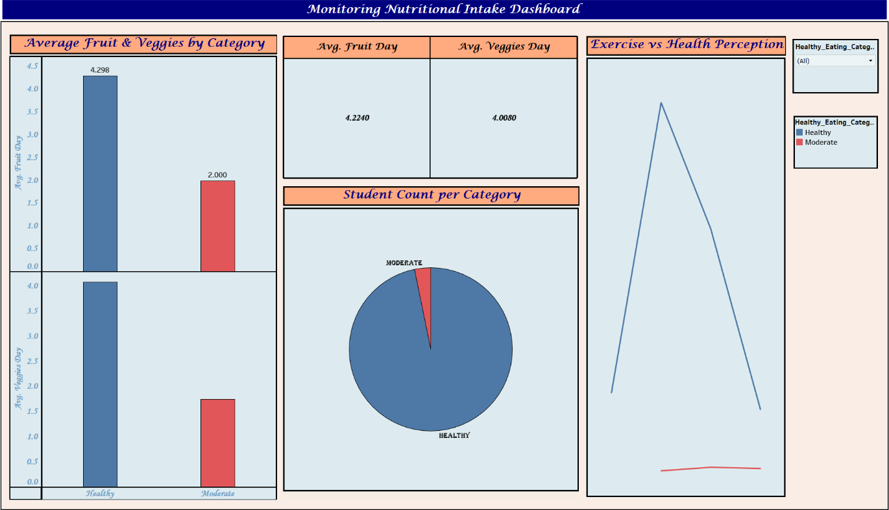

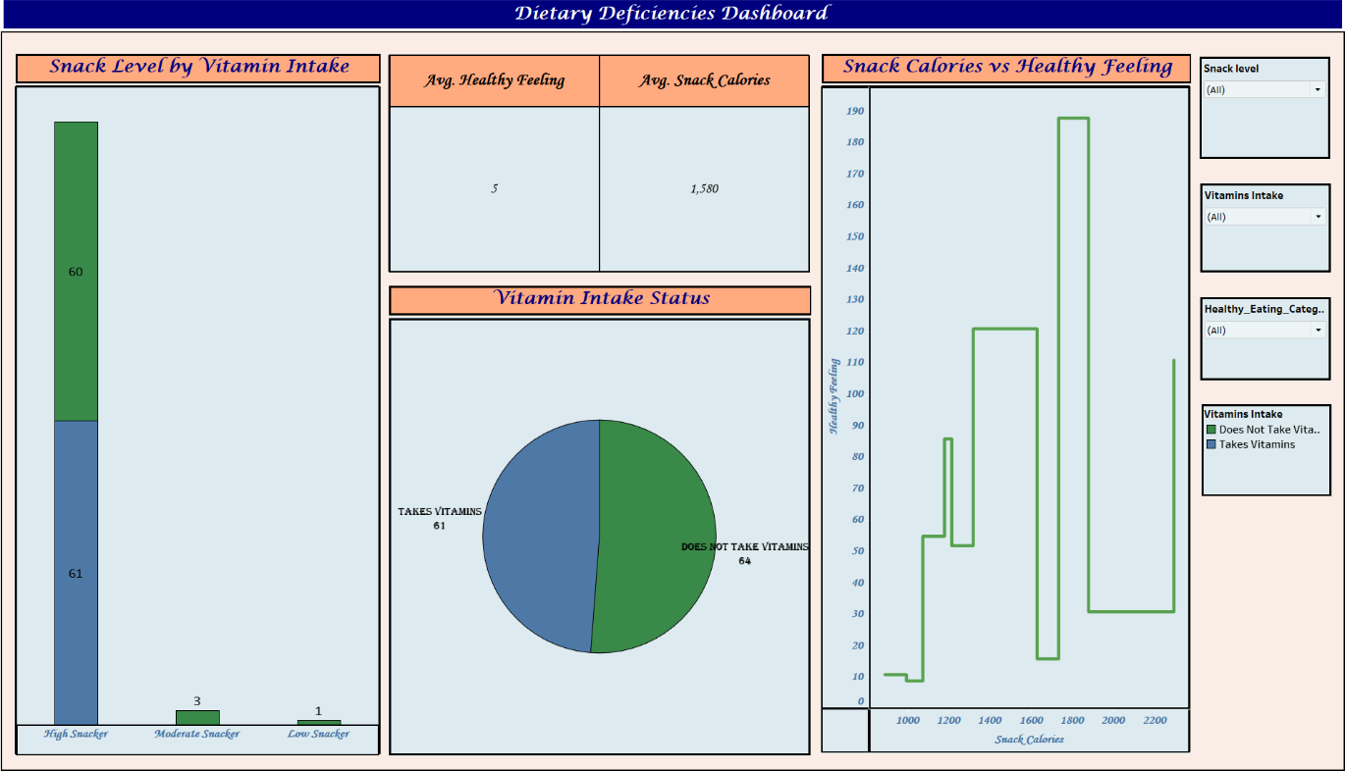

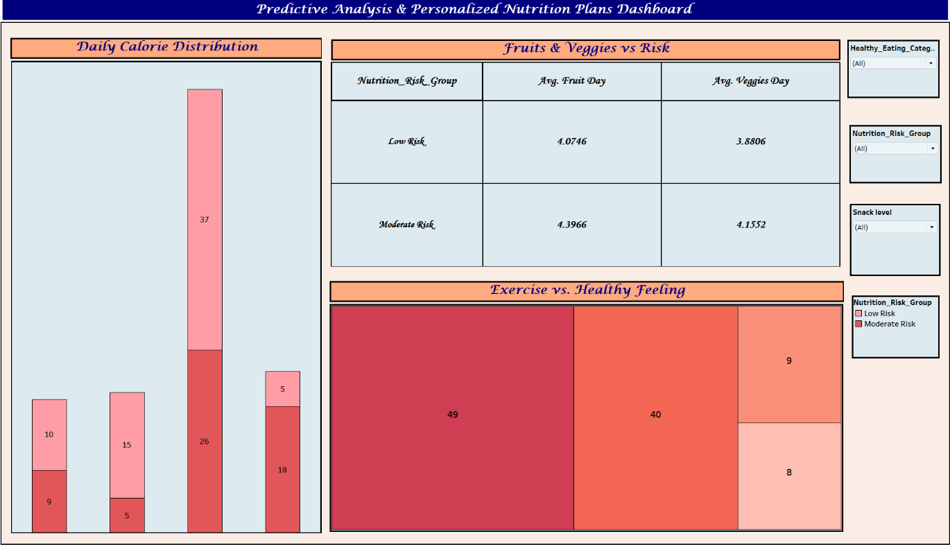

Story:
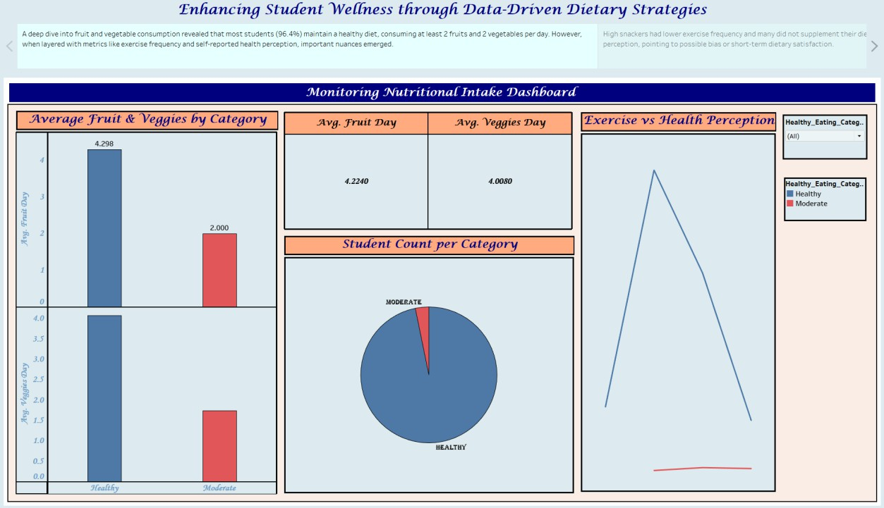

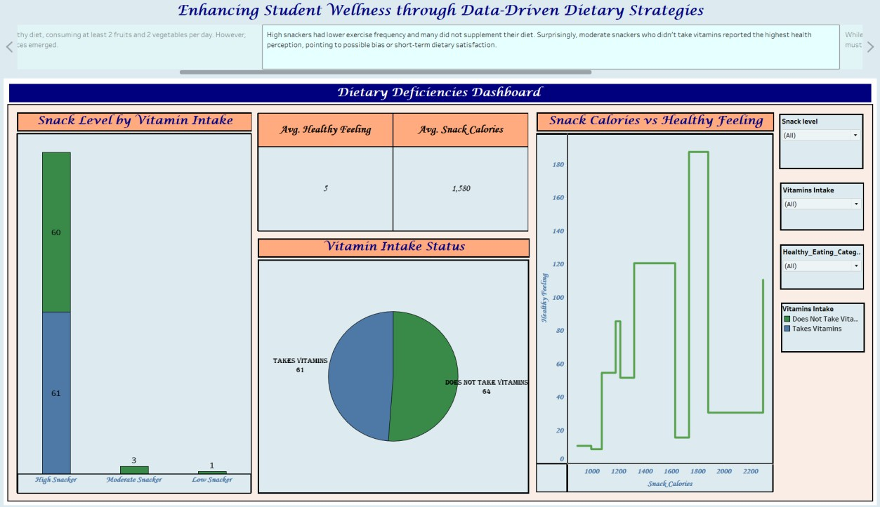

ADVANTAGES AND DISADVANTAGES ADVANTAGES:

Real-Time Insights:
Tableau dashboards allow for up-to-date visualization of student dietary behaviours, helping administrators quickly spot trends and deficiencies.

Data-Driven Decision Making:
Enables evidence-based strategies for improving menu planning, wellness programs, and targeted health interventions.

Centralized Data Integration:
Combines multiple data sources (dining hall menus, nutrition data, student surveys, health records) into one accessible platform.

Improved Student Health Outcomes:
Early identification of dietary deficiencies or poor eating habits can lead to timely support, better physical and mental health, and improved academic performance.

Enhanced Collaboration:
Facilitates cooperation between health services, dining services, and student affairs through shared data insights.

Customizable Visual Dashboards:
Dashboards can be tailored for different audiences—administrators, nutritionists, dining staff, or even students.

Cost-Effective Long-Term Planning:
Helps avoid expensive health interventions later by focusing on prevention through nutrition.

DISADVANTAGES:

Data Collection and Quality Issues:
Accurate and comprehensive data from multiple sources (e.g., dining systems, health records) may be hard to collect, inconsistent, or siloed.

Privacy and Ethics Concerns:
Handling student health and dietary data requires strict compliance with privacy laws (e.g., FERPA, HIPAA) and ethical considerations.

Technical and Resource Limitations:
Building and maintaining Tableau dashboards may require technical expertise, staff training, and ongoing IT support.

Limited Student Participation:
Without consistent student input (e.g., food choices, survey responses), data may be incomplete or unrepresentative.

Resistance to Change:
Dining services or administrative staff may resist adopting new data systems or changing long-standing menu practices.

Initial Time and Cost Investment:
Upfront costs for data integration, software, and training may be significant, especially for smaller institutions.

CONCLUSION

The Comprehensive Analysis and Dietary Strategies with Tableau project represents a forward-thinking approach to improving student health and wellness through data-driven insights. By leveraging Tableau’s powerful visualization capabilities, the project addresses key challenges such as fragmented data, lack of real-time analysis, and reactive health strategies. With integrated dashboards and nutritional analysis tools, college administrators, health professionals, and dining services can collaboratively identify dietary trends, detect nutritional gaps, and implement more effective, targeted interventions.
This initiative not only enhances operational efficiency but also places student well-being at the centre of campus life—fostering a healthier, more informed, and proactive campus community.

FUTURE SCOPE

Predictive Health Analytics:
  - Integrate machine learning tools with Tableau to forecast potential health issues related to diet (e.g., vitamin deficiencies, obesity risk).

Mobile App Integration:
  - Develop or integrate with mobile platforms to allow students to track their meals, receive personalized nutrition tips, and give feedback.

Personalized Nutrition Plans:
  - Use student dietary data to offer tailored meal recommendations based on individual health needs, allergies, or fitness goals.

Expansion to Mental Health Insights:
  - Correlate dietary trends with mental health patterns to support holistic student wellness initiatives.

Collaboration with Academic Departments:
  - Partner with nutrition, public health, or data science departments for student-led research, internships, or capstone projects.

Benchmarking Across Institutions:
  - Share anonymized insights across universities to compare trends, share best practices, and improve nationwide student health strategies.

Sustainability & Food Waste Monitoring:
  - Extend dashboards to analyse food waste and sustainability metrics, aligning dietary planning with environmental goals.

APPENDIX

Source Code:

Index.html
<!DOCTYPE html>
<html lang="en">
<head>
<meta charset="UTF-8">
<title>Combined Nutrition Dashboards</title>
<style> body {
font-family: Arial, sans-serif; margin: 20px;
}
.dashboard-container { margin-bottom: 60px;
}
</style>
</head>
<body>

<!-- Dashboard 1: Monitoring Nutritional Intake -->
<div class="dashboard-container tableauPlaceholder" id="viz1" style="position: relative;">
<noscript>
<a href="#">
<img alt="Monitoring Nutritional Intake Dashboard"

src="https://public.tableau.com/static/images/Mo/MonitoringNutritionalIntakeDashboard/Mo nitoringNutritionalIntakeDashboard/1_rss.png"
style="border: none" />
</a>
</noscript>
<object class="tableauViz" style="display:none;">
<param name="host_url" value="https%3A%2F%2Fpublic.tableau.com%2F" />
<param name="embed_code_version" value="3" />
<param name="site_root" value="" />
<param name="name"
value="MonitoringNutritionalIntakeDashboard/MonitoringNutritionalIntakeDashboard" />
<param name="tabs" value="no" />
<param name="toolbar" value="yes" />
<param name="static_image"
value="https://public.tableau.com/static/images/Mo/MonitoringNutritionalIntakeDashboard/ MonitoringNutritionalIntakeDashboard/1.png" />

<param name="animate_transition" value="yes" />
<param name="display_static_image" value="yes" />
<param name="display_spinner" value="yes" />
<param name="display_overlay" value="yes" />
<param name="display_count" value="yes" />
<param name="language" value="en-US" />
</object>
</div>

<!-- Dashboard 2: Dietary Deficiencies -->
<div class="dashboard-container tableauPlaceholder" id="viz2" style="position: relative;">
<noscript>
<a href="#">
<img alt="Dietary Deficiencies Dashboard"

src="https://public.tableau.com/static/images/Di/DietaryDeficienciesDashboard/DietaryDefic ienciesDashboard/1_rss.png"
style="border: none" />
</a>
</noscript>
<object class="tableauViz" style="display:none;">
<param name="host_url" value="https%3A%2F%2Fpublic.tableau.com%2F" />
<param name="embed_code_version" value="3" />
<param name="site_root" value="" />
<param name="name"
value="DietaryDeficienciesDashboard/DietaryDeficienciesDashboard" />
<param name="tabs" value="no" />
<param name="toolbar" value="yes" />
<param name="static_image"
value="https://public.tableau.com/static/images/Di/DietaryDeficienciesDashboard/DietaryDe ficienciesDashboard/1.png" />
<param name="animate_transition" value="yes" />
<param name="display_static_image" value="yes" />
<param name="display_spinner" value="yes" />
<param name="display_overlay" value="yes" />
<param name="display_count" value="yes" />
<param name="language" value="en-US" />
</object>
</div>

<!-- Dashboard 3: Predictive Analysis -->
<div class="dashboard-container tableauPlaceholder" id="viz3" style="position: relative;">
<noscript>
<a href="#">

<img alt="Predictive Analysis & Personalized Nutrition Plans Dashboard"

src="https://public.tableau.com/static/images/Pr/PredictiveAnalysisandPersonalizedNutrition PlansDashboard/PredictiveAnalysisPersonalizedNutritionPlansDashboard/1_rss.png"
style="border: none" />
</a>
</noscript>
<object class="tableauViz" style="display:none;">
<param name="host_url" value="https%3A%2F%2Fpublic.tableau.com%2F" />
<param name="embed_code_version" value="3" />
<param name="site_root" value="" />
<param name="name"
value="PredictiveAnalysisandPersonalizedNutritionPlansDashboard/PredictiveAnalysisPerso nalizedNutritionPlansDashboard" />
<param name="tabs" value="no" />
<param name="toolbar" value="yes" />
<param name="static_image"
value="https://public.tableau.com/static/images/Pr/PredictiveAnalysisandPersonalizedNutriti onPlansDashboard/PredictiveAnalysisPersonalizedNutritionPlansDashboard/1.png" />
<param name="animate_transition" value="yes" />
<param name="display_static_image" value="yes" />
<param name="display_spinner" value="yes" />
<param name="display_overlay" value="yes" />
<param name="display_count" value="yes" />
<param name="language" value="en-US" />
</object>
</div>

<!-- Story: Enhancing Student Wellness -->
<div class="dashboard-container tableauPlaceholder" id="viz4" style="position: relative;">
<noscript>
<a href="#">
<img alt="Story: Enhancing Student Wellness through Data-Driven Dietary Strategies"

src="https://public.tableau.com/static/images/En/EnhancingStudentWellnessthroughData-DrivenDietaryStrategiesStory/EnhancingStudentWellnessthroughData-DrivenDietaryStrategiesStory/1_rss.png"
style="border: none" />
</a>
</noscript>
<object class="tableauViz" style="display:none;">
<param name="host_url" value="https%3A%2F%2Fpublic.tableau.com%2F" />
<param name="embed_code_version" value="3" />
<param name="site_root" value="" />

<param name="name" value="EnhancingStudentWellnessthroughData-DrivenDietaryStrategiesStory/EnhancingStudentWellnessthroughData-DrivenDietaryStrategiesStory" />
<param name="tabs" value="no" />
<param name="toolbar" value="yes" />
<param name="static_image"
value="https://public.tableau.com/static/images/En/EnhancingStudentWellnessthroughData-DrivenDietaryStrategiesStory/EnhancingStudentWellnessthroughData-DrivenDietaryStrategiesStory/1.png" />
<param name="animate_transition" value="yes" />
<param name="display_static_image" value="yes" />
<param name="display_spinner" value="yes" />
<param name="display_overlay" value="yes" />
<param name="display_count" value="yes" />
<param name="language" value="en-US" />
</object>
</div>

<!-- Common Script to Load All Visualizations -->
<script type="text/javascript">
function renderViz(divId, fallbackHeight) {
var divElement = document.getElementById(divId);
var vizElement = divElement.getElementsByTagName('object')[0];

if (divElement.offsetWidth > 800) { vizElement.style.width = '100%';
vizElement.style.height = (divElement.offsetWidth * 0.75) + 'px';
} else if (divElement.offsetWidth > 500) { vizElement.style.width = '100%';
vizElement.style.height = (divElement.offsetWidth * 0.75) + 'px';
} else {
vizElement.style.width = '100%'; vizElement.style.height = fallbackHeight;
}

var scriptElement = document.createElement('script');
scriptElement.src = 'https://public.tableau.com/javascripts/api/viz_v1.js'; vizElement.parentNode.insertBefore(scriptElement, vizElement);
}

renderViz('viz1', '1327px'); renderViz('viz2', '1477px'); renderViz('viz3', '1227px'); renderViz('viz4', '1327px');

</script>

</body>
</html>

Dataset Link:

https://www.kaggle.com/datasets/borapajo/food-choices?select=food_coded.csv

GitHub Repository Link:

https://github.com/RaghunadhaRao-Kotaru/Comprehensive-Analysis-and-Dietary-Strategies-with-Tableau-A-College-Food-Choices-Case-Study

Project Demo Link:

https://drive.google.com/file/d/17rDWzVLU-tlsuCsbdVFN7ZV8zFx3a7oB/view?usp=sharing

Team Members:

- Chenchu Venkata Sai Pravallika Chaluvadi

- Ruchitha Naladala

- Singamsetty Mounvitha

- Sravan Manchikanti

